DevOps x AWS series

**Project 1**: Setting up a Web App + IDE in the cloud

In this project, you will learn the basics of building a web app. This will lay the foundations for your DevOps work.

Services to use: IAM, EC2 and Cloud9

Step1: set up an IAM user

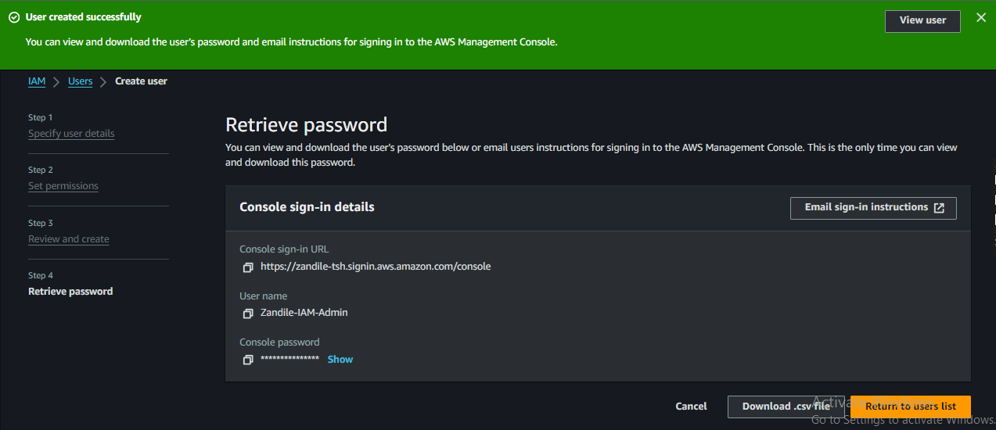

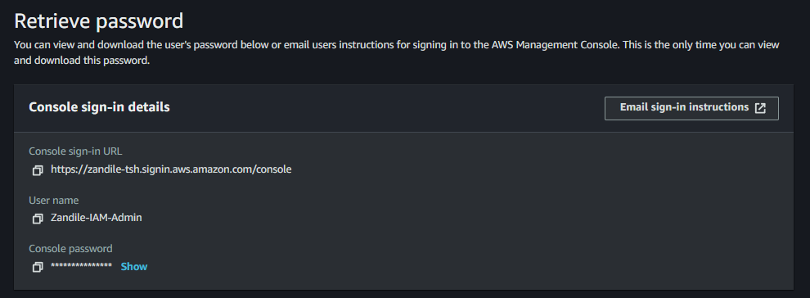

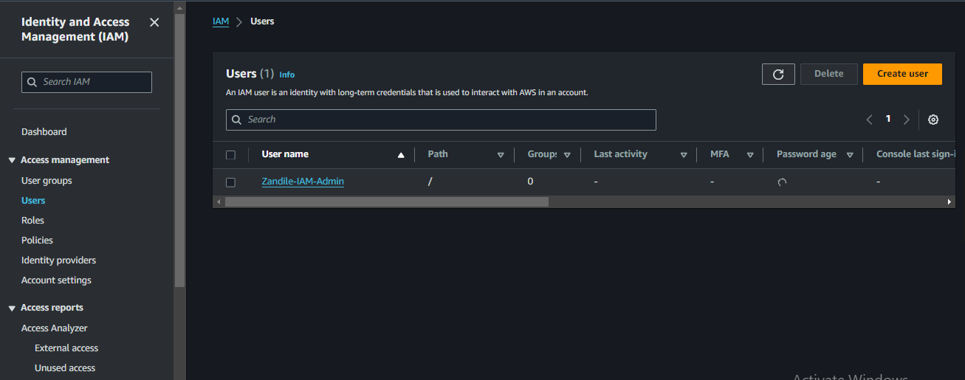

Step 2: **Launch a new Cloud9 IDE**

Error encountered while creating an environment. If you're encountering an issue where Cloud9 cannot connect to your EC2 instance, it's likely due to a network configuration problem in your VPC or security settings.

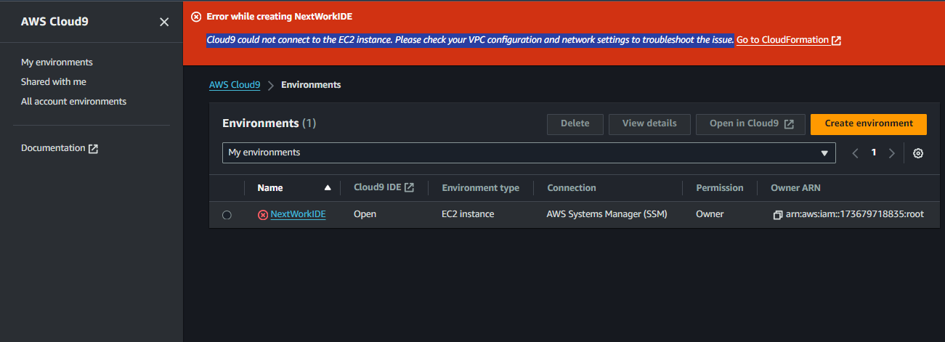

Solution: select SSH under Connection instead of SSM

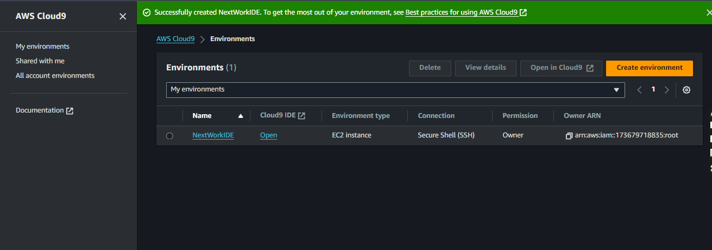

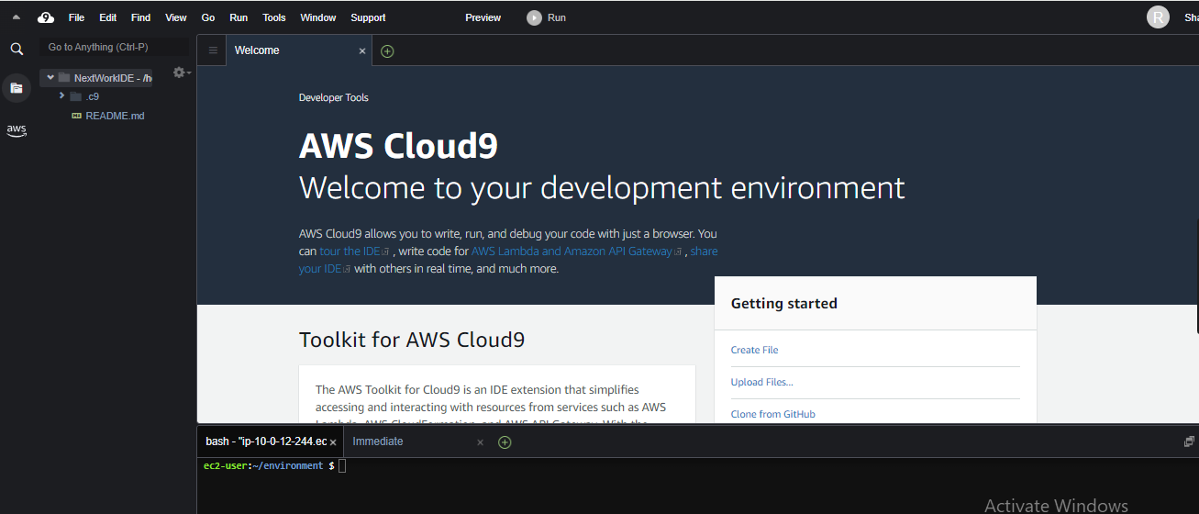

Step 3: **Install Maven & Java**

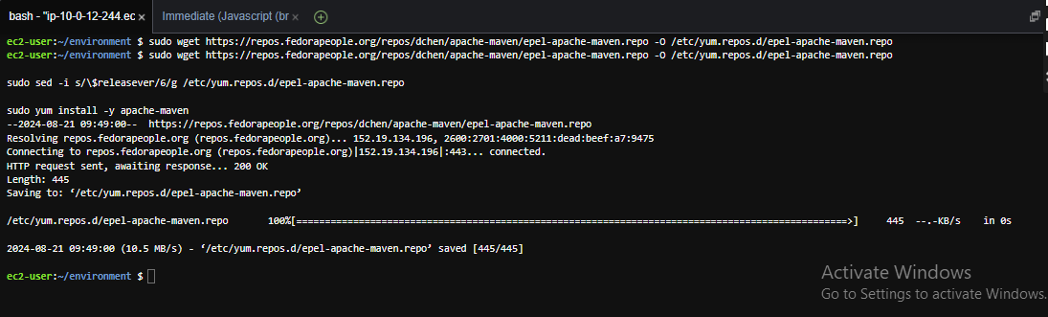

Step 4: **Create the Application**

Today you've learnt how to:

1. 💂 **Set up an IAM user:** You created a new IAM user with admin permissions to provide a safer alternative to using the AWS root account for ongoing projects.
2. ☁️ **Launch a new Cloud9 IDE:** You set up a new Cloud9 IDE environment to write, run, and debug code without installing heavy software locally.
3. ⬇️ **Install Maven & Java:** You installed Apache Maven and Amazon Corretto 8 on your Cloud9 IDE to manage your project's dependencies for developing a Java web application.
4. 🏗️ **Create the application:** Using Maven, you generated a new Java web app from a template, creating a basic project structure and environment for further development.